Lesson Plan

Teacher: Maghiar Liliana
School: Școala Gimnazială „Luceafărul”
Lesson: A knight for a day! (Unit 9c)
Type of the lesson: mixed lesson – teaching and consolidation
Class: 4th B
Vocabulary: New: travel, machine, fence, guard, fight, motorbike + consolidation
Grammar: Consolidation – present continuous
Date: 28th March 2018
Time: 45 minutes

Aims of the lesson:
- to develop the pupils’ listening, reading, speaking, and writing skills;
- to present and activate the vocabulary of the unit;
- to provide guidance in practising the vocabulary and grammar structures.
- to develop the pupils’ attention in order to spot mistakes in a picture;
- to check the comprehension of the text;
- to consolidate the vocabulary and the language taught in the units 9a+b.

Objectives:
By the end of the lesson, pupils will be better able to:
- use the new vocabulary in proper contexts;
- match words with their definitions;
- sing and perform different actions;
- spot mistakes in a picture;
- participate actively in a conversation.

Materials: CD, laptop, cards with dedfinitions, flashcards, textbooks, notebooks, board
Skills: Listening, reading, speaking and writing
Techniques: Exposing, conversation, fill in exercises, listening and reading for specific information, elicitation, dialogue, brainstorming

Anticipated problems:

- some pupils might feel nervous and reluctant to participate in the activity, thus they may need assistance;
- some students might need further help and extra indications in solving the tasks and they may also need some of these indications to be given in Romanian.

Bibliography:
      - Official: The Curriculum for Primary Education
      - Methodical: - Harmer, Jeremy. 2001. The Practical of English Language Teaching. Pearson Education Limited; - Scrivener, Jim. 2011. Learning teaching. Macmillan Publishers Limited
      - Textbook: Dooley, Jenny; Evans, Virginia. Limba modernă – engleză, Clasa a IV-a, Semestrul 2. Express Publishing

STAGES OF THE LESSON

- Warm-up
Aim:
- to create a relaxed and pleasant atmosphere

Time: 3 minutes
Interaction: T - pupils, pupils -T
Procedure:
Teacher greets the pupils, asks about their mood and the pupils answer. Teacher checks the attendance, then the pupils sing the Spring song.

- Lead-in

Aim:
- to consolidate the language of units 9a+b

Time: 10 minutes
Interaction: T- pupils, pupils -T
Procedure:
T. announces the pupils that they will play the game “Who has got?” in order to consolidate the language of units 9a+b, using flashcards.
T. hands out the flashcards to different pupils and she asks: Who has got: eg. the chess flashcard? The pupil who has the corresponding flashcard stands up and shows the flashcard to the rest of the class. The class applaud and the T. encourages the pupils to say/repeat the words after her. Then she asks them to pass the flashcards on to different pupils and repeats the procedure.

- Presentation and practice
Aim:
- to present and activate the vocabulary of the unit

Time: 10 minutes
Interaction: T- pupils, pupils –T
Procedure:
T. writes a big 28 on the board and asks the pupils to open their books at page twenty-eight. T. reads the title of the unit and has pupils repeat after her. T. elicits / explains what the title means, writes the title and the date on the board and the pupils copy in their notebook. Teacher informs the pupils about the lesson’s aims.

T. introduces/writes the new vocabulary on the board and each new word is taught with the help of flashcards.

T. announces the pupils that she has prepared some cards on which there are written definitions of the new words and spreads them among the pupils. T. invites the pupils, in turn, to read aloud the definitions and to match them with the flashcards. (Annex I).

- Listening
Aim:
- to develop the pupils’ listening skills;
- to check the comprehension of the text.

Time: 5 minutes
Interaction: T - pupils, pupils –T
Procedure:
Ex. 1 / page 28. T. reads the instructions and explains the task. T. plays the song on the recording. The pupils listen and follow the lines.

T. plays the recording again. The pupils listen and sing along, while watching the video.

Life was so fine, you know,
Hundreds of years ago.
I wish there was a way
To be a knight for just one day.!
They lived in big castles,
They danced with the Queen.
They travelled on horses
And looked like machines!
They fenced in the morning
And played chess at night.
They guarded the castle
And learned how to fight!

- Speaking
Aims:
- to develop the pupils’ speaking skills;
- to provide guidance in practising the vocabulary and grammar structures.
- to develop the pupils’ attention in order to spot mistakes in a picture.

Time: 10 minutes
Interaction: T - pupils, Pair work, Whole class work

Procedure:
Ex. 2 / page 28. T. reads the instructions and explains the task. T. refers the pupils to the dialogue and reads it aloud. T. asks the pupils to work in pairs: to ask and answer questions and say what the knights are doing. T. goes around the classroom monitoring the activity and correcting mistakes, where necessary.

e.g. Pupil 1: Two! What is the knight doing?
Pupil 2: He’s guarding the castle.
Pupil 1: Three! What is the knight doing?
Pupil 1: He’s listening to music. etc

T. refers the pupils to the picture in Ex. 1. T. tells them that there are some mistakes in the picture regarding what activities knights did hundreds of years ago, and that they have to spot these mistakes. T. asks them to look carefully and to say which activities are wrong.

Answers: the knight watching TV, the knight riding a motorbike, the knight listening to music, the knight playing baseball

- Reading and writing
Aim:
- to develop the pupils’ reading and writing skills;
- to consolidate the vocabulary and the language taught in the units 9a+b+c.

Time: 5 minutes
Interaction: T – pupils, Group work
Procedure:
Annex 2. T asks the pupils to form groups of 3 or four, to read the instructions and to do the task. After they finish, each group will say two words from the list, and the others check and correct where necessary.

Answers: 1. Knight 2. Bake 3. Chess 4. Castle/palace 5. Queen 6. Carry 7. sail 8. Suit of armour 9. Oven 10. Butler 11. Deer 12. Feast 13. King 14. Hunt

- Homework assignment
Aim:
- to provide further practice of the vocabulary and the structure of the unit

Time: 2 minutes
Interaction: T - pupils
Procedure:
Annex 3. T. reads the instructions and explains the task. T. asks the pupils to file the paper in their Junior Language Portfolios.

BOARD SCHEME

28th March 2018
A knight for a day!

28
Homework
Annex 3

to travel = a călători
machine = aparat
to fence = a face scrimă
to guard = a păzi
to fight = a lupta
motorbike = motocicletă

ANNEX 1

Definitions to be matched:

A piece of equipment with several parts that uses power to do a particular type of work.
To fight as a sport with a long, thin sword.

To use physical force to try to defeat another person or group of people.
To protect someone or something from being attacked or stolen

To make a journey, usually over a long distance.

A small motorcycle.

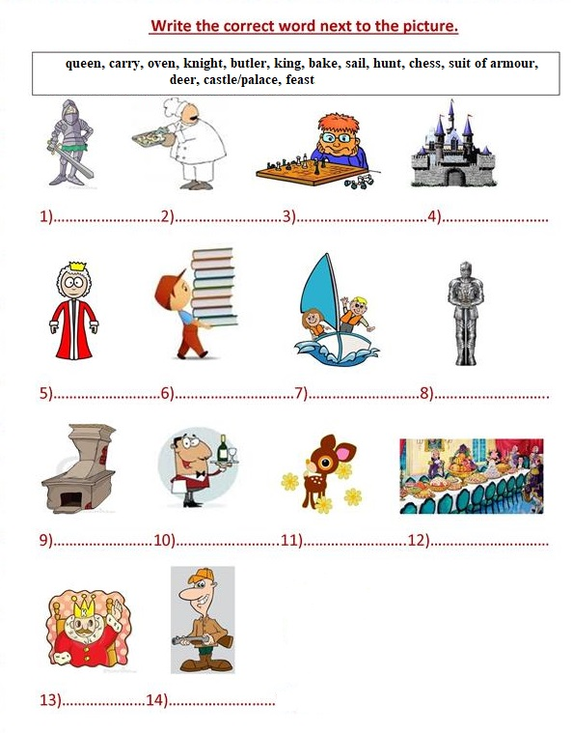

HOMEWORK

Draw and write as in the example. You can be a: king, prince, princess, butler, knight, hunter or somebody else for a day, at your choice.

I am a queen for a day! I’m wearing a crown and a beautiful dress.

HOMEWORK

Draw and write as in the example. You can be a: king, prince, princess, butler, knight, hunter or somebody else, at your choice.

I am a queen for a day! I’m wearing a crown and a beautiful dress.

LESSON SCHEME

- WARM UP – 3 MIN [ 10:50 – 10:53 ]
- GREETINGS
- SONG – SPRING IS HERE

- LEAD–IN – 10 MIN [ 10:53 - 11:03 ]
- WHO HAS GOT? - GAME

- PRESENTATION AND PRACTICE - 10 MIN [ 11:03 – 11:13 ]
- BIG 28 ON THE BOARD
- TITLE + DATE ON THE BOARD
- EXPLAIN THE TITLE MEANING
- LESSON’S AIMS
- NEW VOCABULARY – USING THE FLASHCARDS
- MATCH THE DEFINITIONS WITH THE FLASHCARDS

- LISTENING – 5 MIN [ 11:13 – 11:18 )
- LISTEN AND FOLOW THE LINES
- WATCH AND SING

- SPEAKING - 10 MIN [ 11:18 – 11:28 ]
- EX 2: PAIR WORK: ASK AND ANSWER (2: What is the knight doing? He’s guarding the castle.)

- WHOLE CLASS WORK: SPOT THE MISTAKES
Answers : the knight watching TV, the knight riding a motorbike, the knight listening to music, the knight playing baseball

- READING AND WRITING – 5 MIN [ 11:28 – 11:33 ]
- GROUP WORK: ANNEX 2
Answers: 1. Knight 2. Bake 3. Chess 4. Castle/palace 5. Queen 6. Carry 7. sail 8. Suit of armour 9. Oven 10. Butler 11. Deer 12. Feast 13. King 14. Hunt

- HOMEWORK ASSIGNMENT – 2 MIN [ 11:33 – 11:35 ]
- ANNEX 3 – PUT IT IN YOUR PORTFOLIOS

